Feedback on the AON web site
- The site navigation from the home page could be more clear. The 3 web map viewer applications are currently located under the “CADIS Data Portal” page:

Partially duplicated, the “AON-CADIS Map Server” link on the table of contents links to the “MapSurfer” viewer only:

It would be less confusing if there was only one path to all three viewers. IE., if “AON-CADIS Map Server” were re-labeled “AON-CADIS Web Map Viewers” or simply “Web Map Viewers”, linking to a page showing the 3 thumbnails and short descriptions for each application.

- Yes, you are right. But http://www.aoncadis.org/ is going away soon, leaving only http://aoncadis.ucar.edu/home.htm . If its not ‘soon enough’, I’ll ask to have this fixed.

- On the CADIS Data Portal page, under “View NSF AON Projects”, the thumbnail screenshot for the middle choice, the one CADIS and ARMAP developed together, is outdated. I’m including two updated screenshots below you could choose from to use.

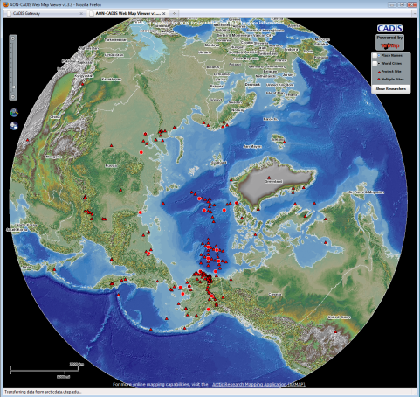 or 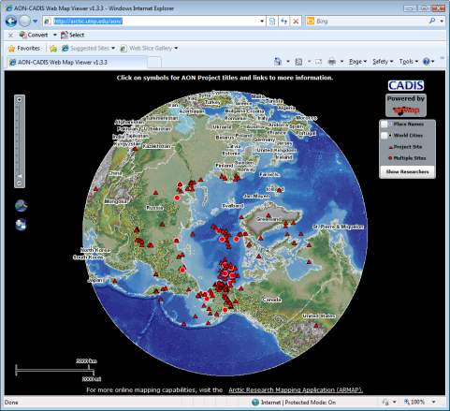

Thanks, we will use the left one (probably).

- Also, the current short description under the application thumbnail is misleading. (This map viewer is different from ARMAP)
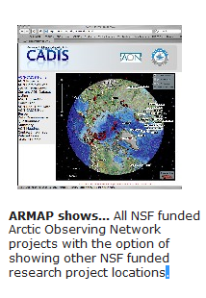
The following would be more accurate:
“The AON-CADIS Web Map Viewer shows … the locations of Arctic Observing Network projects with links to relevant data pages.”

- By the similar sentence structure for the 3 ways of looking at the AON data sites on a map I was trying to hilight differences very briefly. All 3 have links to relevant data pages. I think what’s uniquely valuable about the map viewer you’ve provided is that people can also see all the other NSF funded arctic research – at least through ARMAP. How about this: “Web Map Viewer shows … the locations of Arctic Observing Network projects with the option of showing other NSF funded work through ARMAP. We suggest you START HERE unless you prefer a full GIS or Google Earth interface. “ It would get across that this is quickest and most user friendly.

- Similarly, could you please modify the extended pop up description?:
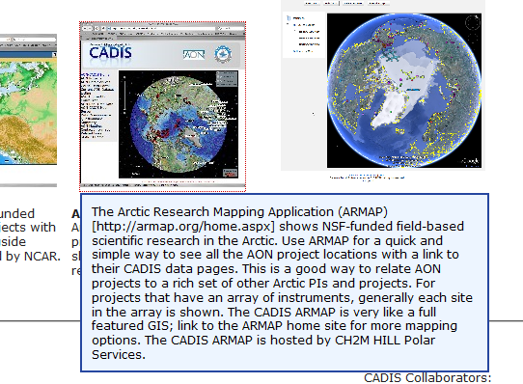
Something along these lines would be more appropriate:
“Use the AON-CADIS Web Map Viewer (http://arctic.utep.edu/aon/) for a quick and simple way to see all AON project locations, with links to their CADIS data pages. Click on symbols for project titles and links. Click on “Show Researchers” to customize the symbols by PI. This viewer is hosted by the University of Texas at El Paso and was developed in collaboration with the Arctic Research Mapping Application (ARMAP), which provides additional mapping capabilities at http://armap.org.

That’s fine, will do.

